

Pug uglies petshop



Team Members

Jafor Ahmed, [jaforahmed1042@gmail.com](mailto:jaforahmed1042@gmail.com)

Shobhit Ratan, <shobhit.ratan@baruchmail.cuny.edu>

Guan Chen [gchen2381@gmail.com](mailto:gchen2381@gmail.com)

Adam Ocasio, [adam.ocasio@baruchmail.cuny.edu](mailto:adam.ocasio@baruchmail.cuny.edu)

Mathew Boccio, <matthew.boccio711@gmail.com>

December 10, 2015

Group 2

Group Name: Black Mambas

# CIS 3400: Database Management Systems

# Section: FTRA

# Prof. Bill Ferns

# Fall 2015

TABLE OF CONTENTS

Introduction 2

**Current Data Management Practices 2**

**Business Process PUP performs 3**

**Problems with Current System 3**

How we plan to Help Pup 4

Information used to implement proposed solution 5

PUP E-R Diagram Design Assumptions 5

E-R Diagram 6

Converting e-r diagram to relations 7

functional dependencies 7

normalization 8

**Access database 9**

**conclusion 28**

**Introduction**

Rafael Parikh and Aida Chin own Pug Uglies Petshop. Their pet shop sells food and other supplies to pet owners. The owners of the pet shop want to automate the recordkeeping process to keep better track of what is selling. They would also like a better inventory system that keeps track of supplies as well as knowing when and what to reorder. Their current system is quite dated, it lacks congruency and consistency. Pug Uglies have multiple repeat customers and want to model a business plan that focuses on being more personal with their customers and create customer loyalty. What we want to do is help them develop a system that can efficiently keep track of their sales and effectively maintain their inventory.

**Current Data Management Practices**

Many customers that shop at Pug Uglies Petshop are reoccurring customers. Majority of the revenue generated are produced through large volumes of retail sales from pet supplies.

When a sale is made at PUP a clerk must go through binders and manually update the inventory to show what items have been purchased. For each item that is sold PUP keeps descriptive information in other binders. Keeping track of:

* Stock keeping unit (SKU) #
* Items name
* Item description
* Cost per unit
* Suggested retail price / unit
* Quantity on hand
* Reorder point

Every item has a price stamped on to them. If the price is not on the item the clerk must look up the price in the binder.

**Business Processes PUP Performs**

Pug Uglies Petshop generally have many repeat customers. Customers typically buy more than one item at a time and they will often buy several units of each item. Listed below is the basic business process:

1. Customer makes a purchase.
2. PUP keeps descriptive information on item sold as a hardcopy.
3. PUP records cost of item, sold item price and quantity on hand.
4. They then determine what items need to be reordered in inventory.

All business processes information is kept as hardcopies in binders.

**Problems with Current System**

Pug Uglies Petshop currently does not have an efficient system in place that is consistent and automated. Most of their records are kept in hard copy and many records they don’t keep track of at all. Most of their book keeping is done manually. Making them susceptible to making errors. Their inventory is unorganized and not segmented into categories. This makes it difficult for PUP to understand what kind of pet supplies they sell more of and need in constant supply.

Listed below are a number problems PUP needs to resolve:

* No record of sales orders
* No record of customers
* No record of customer pets
* No record of purchase history
* Lack of customer relations
* Manual book keeping
* Unorganized inventory system
* Inefficient reorders
* Lack of complete database

**How we plan to help PUP**

Pug Uglies Petshop wants to build a stronger relationships with their customers. In creating higher customer loyalty we plan to help them maintain a customer database that will insure them better customer service. We want to help create a system, keep intensive records of sales, have a better understanding of their inventory, as well as managing an efficient supply chain. There are multiple areas we believe we can help automate and manage.

Necessary requirements and desirable changes are as listed below:

***Necessary requirements***

* Having a complete database with customer relevant information.
* Keeping track of customer sales and purchase history.
* A system that automatically looks up the price of an item.
* Have up to date information of inventory.
* Keep track of which items are moving fast and move slow.
* Accurate reports that informing PUP items to reorder.
* Categorize PUP’s inventory for tracking purposes.

***Desirable change***

* Build customer loyalty
* Knowing customers pet
* Name of the pet
* Type of pet ( e.g., cat, dog, bird)
* Age of pet

**Information used to Implement Proposed Solution**

The information we plan to use to implement these changes is as follows:

* Customer name and relevant customer information.
* Information about customer pets (name, type, age etc)
* Inventory categorization by food, toy and grooming categorizes.
* Inventory information such as name, description, cost, quantity and minimum stock levels for reorder.
* Tracking purchase history of customers with sales orders.
* Accurate reporting’s for items sold and quantity.

**PUP E-R Diagram Design Assumptions**

The assumptions for designing UML E-R diagram for Pug Uglies Petshop are as follows:

1. A Customer can have many Pets of the same type or different types. Customer 1..* Pets
2. A Customer can have many SalesOrders. Customer 1..* Many
3. LineItem is a weak entity to SalesOrder. To keep track of Quantity sold at what retail price. SalesOrder 1..* LineItem
4. Inventory can have many SalesOrders . Inventory 1..* SalesOrder
5. There can be many ItemCategories in Inventory Entity. ItemCategory 1..* Inventory
6. Primary / Composite keys for various entities are as given below :

|  |  |  |
| --- | --- | --- |
| **Sl** | **Entity** | **Primary /Composite Key** |
| 1 | Customer | CustomerID |
| 2 | Inventory | SKU# |
| 3 | SalesOrder | OrderID |
| 4 | ItemCategory | CategoryID |
| 5 | Pet | PetID |
| 6 | LineItem(weak entity) | OrderID+Line# |

*Attribute PetType of the ‘Pet’ entity will be normalized in subsequent stage of design with attributes PetType# and TypeDescription

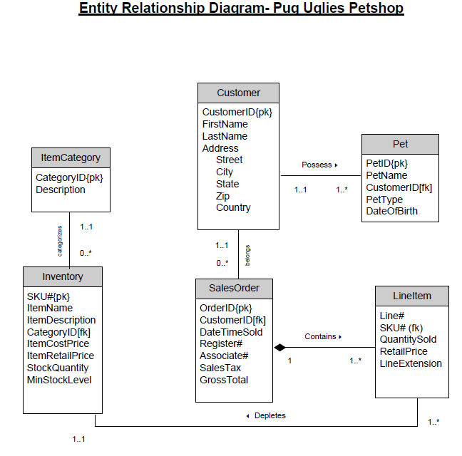

**Converting ERD to Relations**

**CUSTOMER** (CustomerID, FirstName, LastName, Address, Street, City, State, Zip, Country)

**SALESORDER** (OrderID, *CustomerID,* DateTimeSold, Register#, Associate#, SalesTax ,GrossTotal)

**LINEITEM** (Line#, OrderID, *SKU#* Description, QuantitySold, RetailPrice, LineExtentison)

**PET** (PetID, PetName, *CustomerID,*  PetType, DateOfBirth)

**INVENTORY** (SKU# , ItemName, ItemDescription, *CategoryID,*  ItemCostPrice, ItemRetailPrice, StockQuantity, MinStockLevel)

**ITEMCATEGORY** (CategoryID, Description)

**Functional Dependencies**  
  
 The functional dependencies transcribed below describes the relationship between each attribute to a relation. The following is a collection of functional dependencies for PUP:

CustomerID FirstName, LastName, Address, Street, City, State, Zip, Country

OrderID *CustomerID,* DateTimeSold, Register#, Associate#, SalesTax ,GrossTotal

Line#,OrderID *SKU#,* QuantitySold, RetailPrice, LineExtentison

PetID PetName, PetType, DateOfBirth, *CustomerID*

SKU# ItemName, ItemDescription, *CategoryID,* ItemCostPrice, ItemRetailPrice, StockQuantity, MinStockLevel

CategoryID Description

**Normalization**

Normalization is useful to resolve anomalies found in a database. Through normalization PUP can save space and minimize redundant data. It will make their system perform faster by reducing additional table look-ups for information. Normalization will help PUP business processes be more efficient, effective and accurate.

As seen from the dependencies, we observe that there are no partial dependencies or transitive dependencies. Hence the relations in the third normal form (3NF) are as shown below :

**CUSTOMER (3NF)** (Customer ID, FirstName, LastName, Address, Street, City, State, Zip, Country)

**SALESORDER(3NF)** (OrderID, *CustomerID* DateTimeSold, Register#, Associate#, SalesTax, GrossTotal)  
 **LINEITEM (3NF)** (Line#, OrderID*,* *SKU#*, QuantitySold, RetailPrice, LineExtentison)

**INVENTORY(3NF)** (SKU#, *CategoryID*, ItemName, ItemDescription, ItemCostPrice, ItemRetailPrice, StockQuantity, MinStockLevel)

**PET (3NF)** (PetID, *CustomerID*, PetName, PetType, DateOfBirth)

**ITEMCATEGORY (3NF)** (CategoryID**,** Description)

**Access Database**

1. **Relationship**

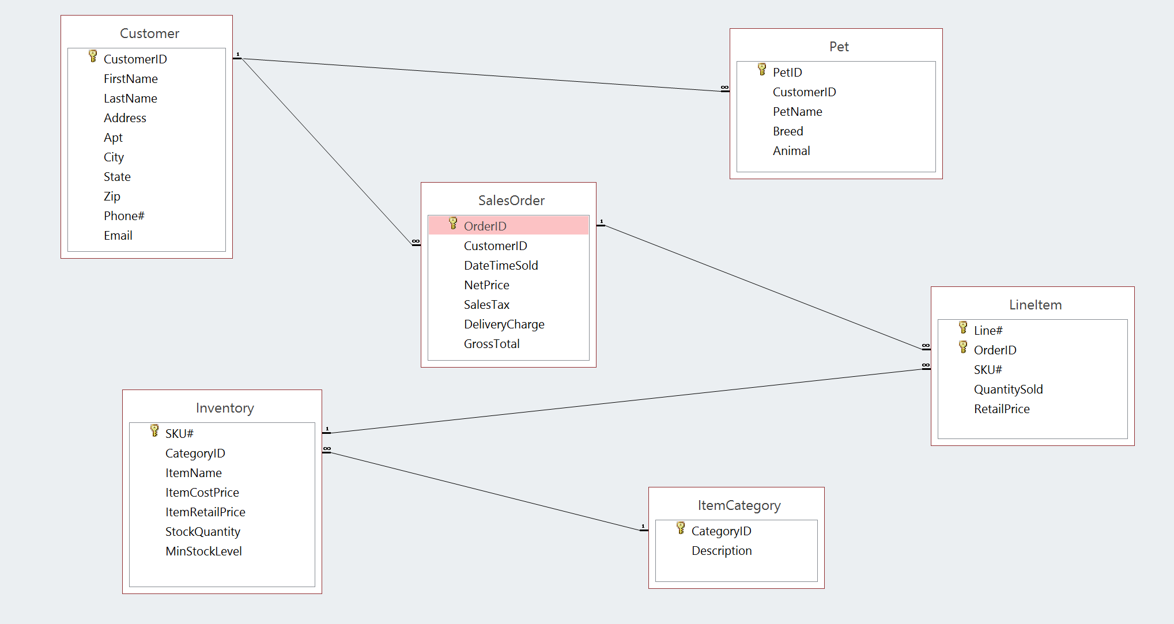

1. **Customer Table Design View**

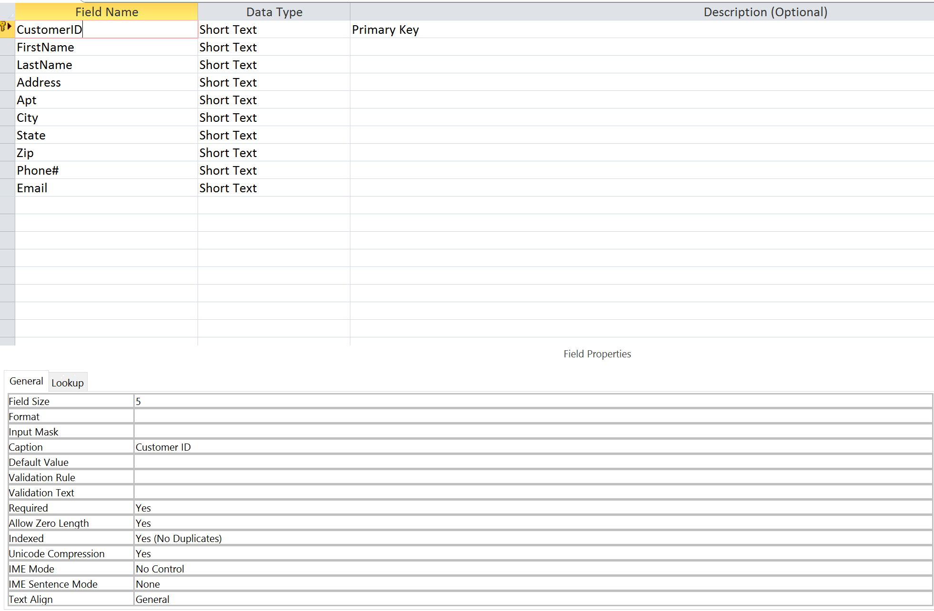

1. **Customer Table**

| **Customer** | | | | | | | | | |
| --- | --- | --- | --- | --- | --- | --- | --- | --- | --- |
| **Customer ID** | **First Name** | **Last Name** | **Address** | **Apt** | **City** | **State** | **Zip** | **Phone#** | **Email** |
| A1281 | Andrews | Steven | 12-48 Avery Ave | Basement | LIC | NY | 11355- | (718) 345-1234 | sandrews@hotmail.com |
| A9874 | Aminova | Terry | 300 South 4th Street | #420 | Williamsburg | NY | 11121- | (347) 555-5432 | T.Aminova@nyc.gov |
| M1121 | Morales | Amanda | 456 E. 77th Street | 2-Z | New York | NY | 10025- | (212) 767-9876 | morales@metmuseum.org |
| P0101 | Patel | Vincent | 2777 Broadway | 101 | New York | NY | 10028- | (646) 432-1231 | V_Patel@verizon.net |
| T4291 | Tsang | Elise | 88 South Street | 5-A | New York | NY | 10012- | (212) 545-4321 | ET@aol.com |

1. **Pet Table Design View**

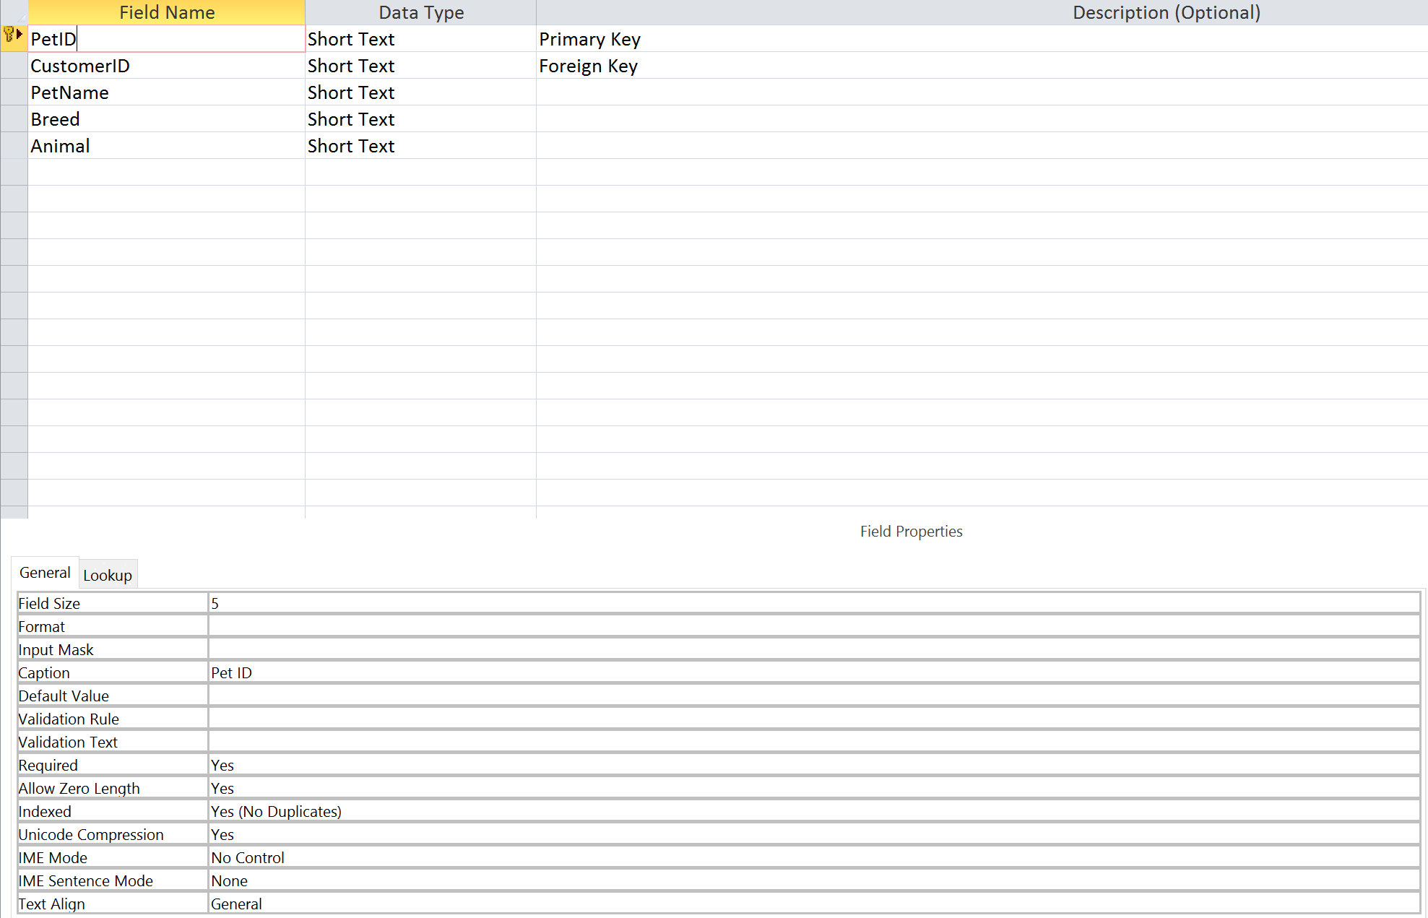

1. **Pet Table**

| **Pet** | | | | |
| --- | --- | --- | --- | --- |
| **Pet ID** | **Customer ID** | **Pet Name** | **Breed** | **Animal** |
| MP11 | M1121 | Fettucine | Domestic Short Hair | Feline |
| MP12 | M1121 | Pesto | Munchkin | Feline |
| P123 | A1281 | Lassie | Collie | Canine |
| P234 | A1281 | Leo | Siamese | Feline |
| PD | P0101 | Oscar | Dog | Canine |
| TA12 | T4291 | Petey | Miniature Poodle | Canine |
| TA13 | T4291 | Paulie | Rat Terrier | Canine |
| TA14 | T4291 | Francesca | Rat Terrier | Canine |

1. **SalesOrder Table Design View**

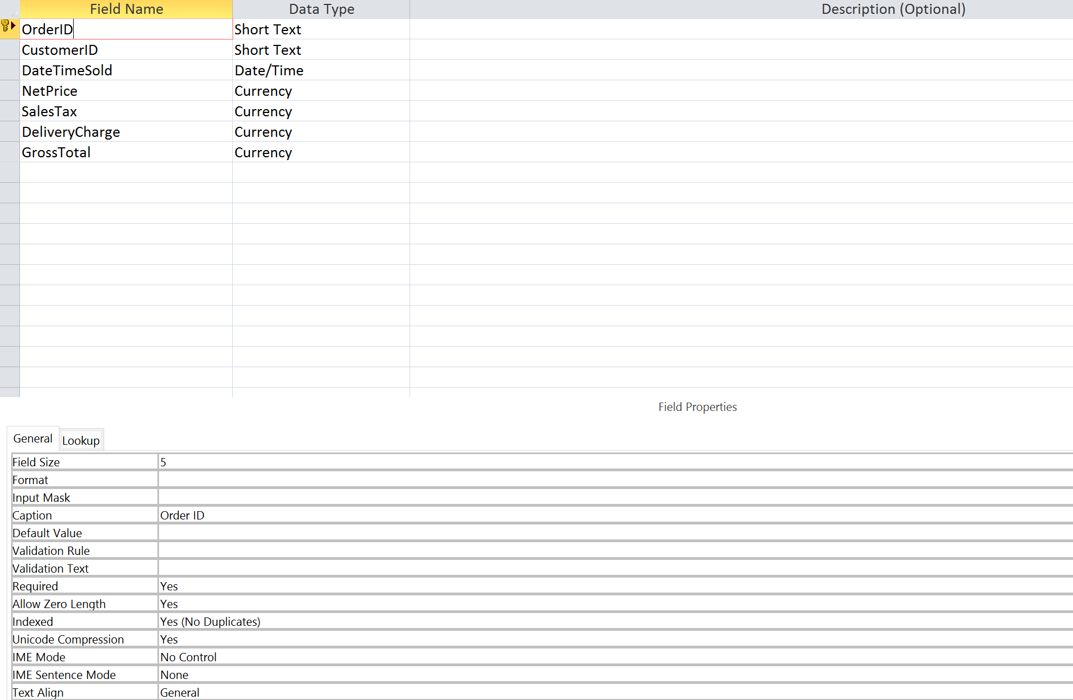

1. **SalesOrder Table**

| **SalesOrder** | | | | | | |
| --- | --- | --- | --- | --- | --- | --- |
| **Order ID** | **Customer ID** | **Date Time Sold** | **Net Price** | **Sales Tax** | **Delivery Charge** | **Gross Total** |
| S0001 | T4291 | 02/10/2015 | $43.90 | $3.79 | $5.00 | $52.69 |
| S0002 | M1121 | 02/13/2015 | $46.45 | $4.01 | $0.00 | $50.46 |
| S0003 | P0101 | 02/14/2015 | $18.00 | $1.55 | $0.00 | $19.55 |
| S0004 | T4291 | 02/14/2015 | $96.00 | $8.28 | $5.00 | $109.28 |
| S0005 | M1121 | 02/21/2015 | $17.75 | $1.53 | $0.00 | $19.28 |
| S0006 | P0101 | 02/25/2005 | $49.95 | $4.31 | $0.00 | $54.26 |
| S0007 | A9874 | 02/25/2015 | $30.95 | $2.67 | $0.00 | $33.62 |
| S0015 | M1121 | 03/01/2015 | $39.50 | $3.41 | $0.00 | $42.91 |

1. **LineItem Table Design View**

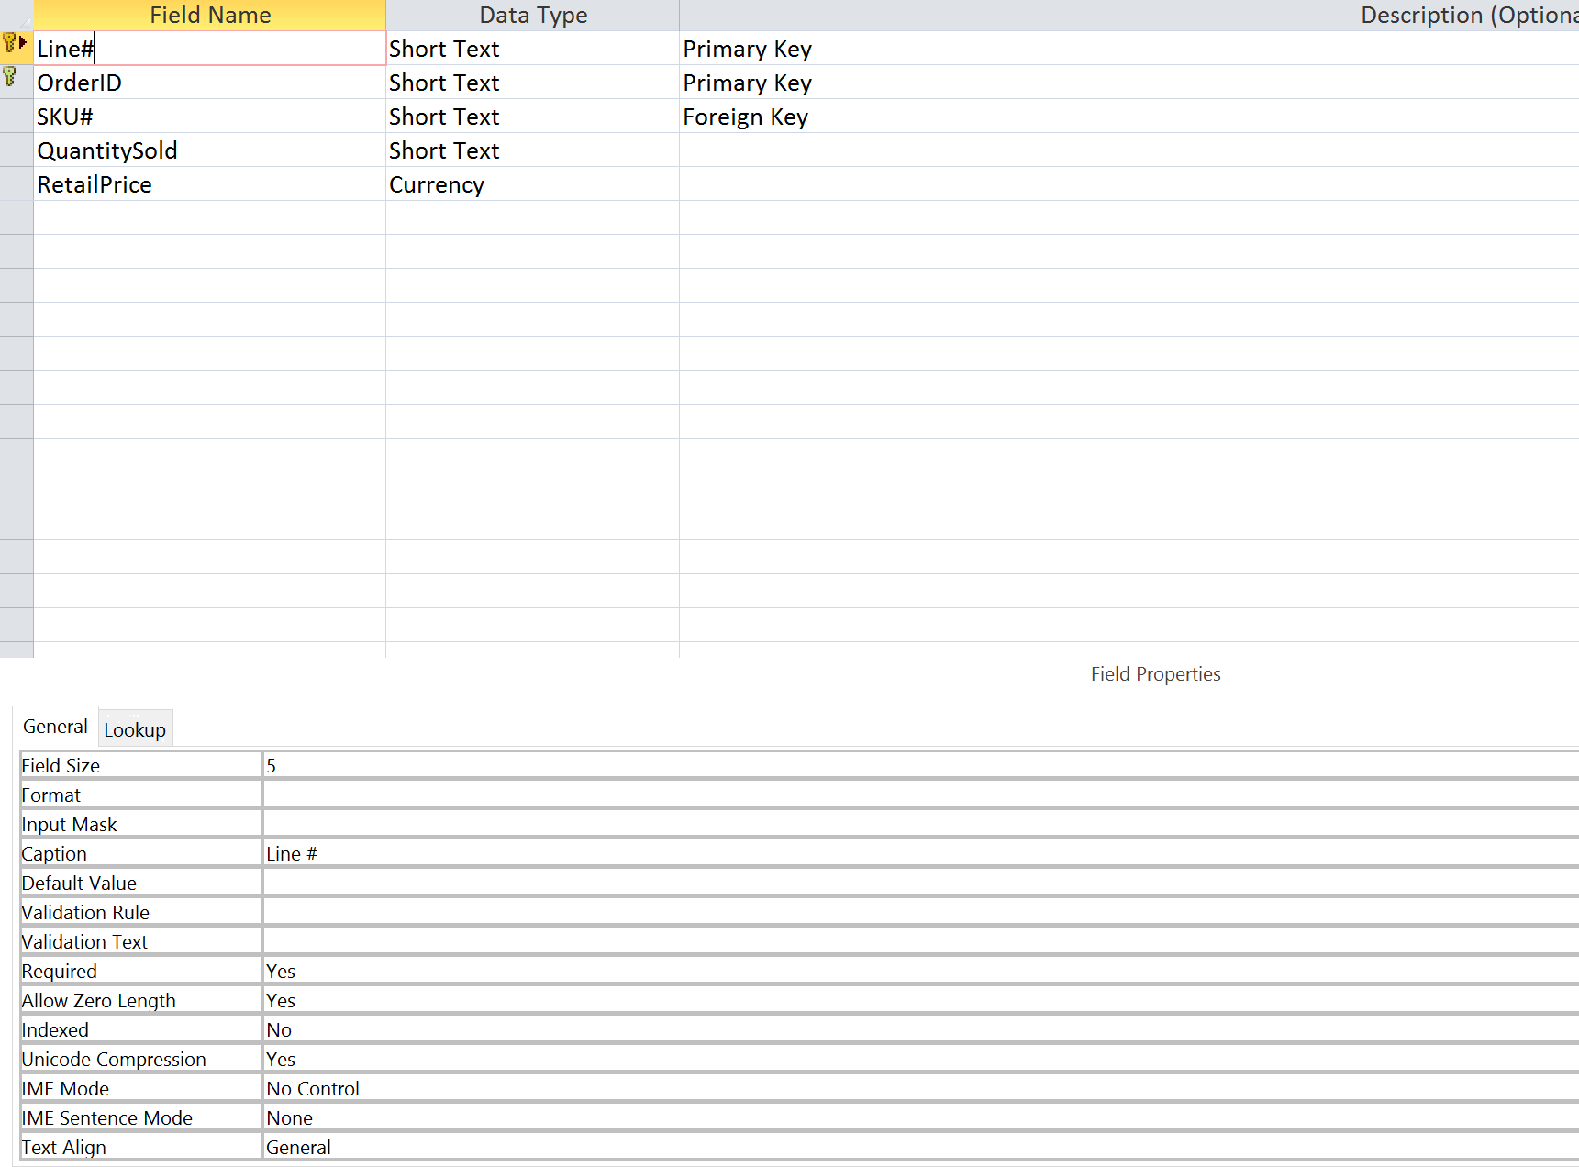

1. **LineItem Table**

| **LineItem** | | | | |
| --- | --- | --- | --- | --- |
| **Line #** | **Order ID** | **SKU #** | **Quantity Sold** | **Retail Price** |
| 1 | S0001 | TL2156 | 2 | $6.95 |
| 1 | S0002 | MC1011 | 24 | $0.90 |
| 1 | S0003 | FF4324 | 12 | $1.50 |
| 1 | S0004 | GI1562 | 2 | $7.00 |
| 1 | S0005 | TL2156 | 1 | $6.95 |
| 1 | S0006 | TL2156 | 1 | $6.95 |
| 1 | S0007 | TL2156 | 1 | $6.95 |
| 1 | S0015 | KK2212 | 2 | $8.95 |
| 2 | S0001 | FF4324 | 20 | $1.50 |
| 2 | S0002 | TL2156 | 1 | $6.95 |
| 2 | S0004 | CC1157 | 1 | $10.00 |
| 2 | S0005 | MC1011 | 12 | $0.90 |
| 2 | S0006 | GI1562 | 1 | $7.00 |
| 2 | S0007 | GI1562 | 2 | $7.00 |
| 2 | S0015 | MC1011 | 24 | $0.90 |
| 3 | S0002 | KK2212 | 2 | $8.95 |
| 3 | S0004 | FF4324 | 48 | $1.50 |
| 3 | S0006 | FF4324 | 24 | $1.50 |
| 3 | S0007 | CC1157 | 1 | $10.00 |

1. **Inventory Table Design View**

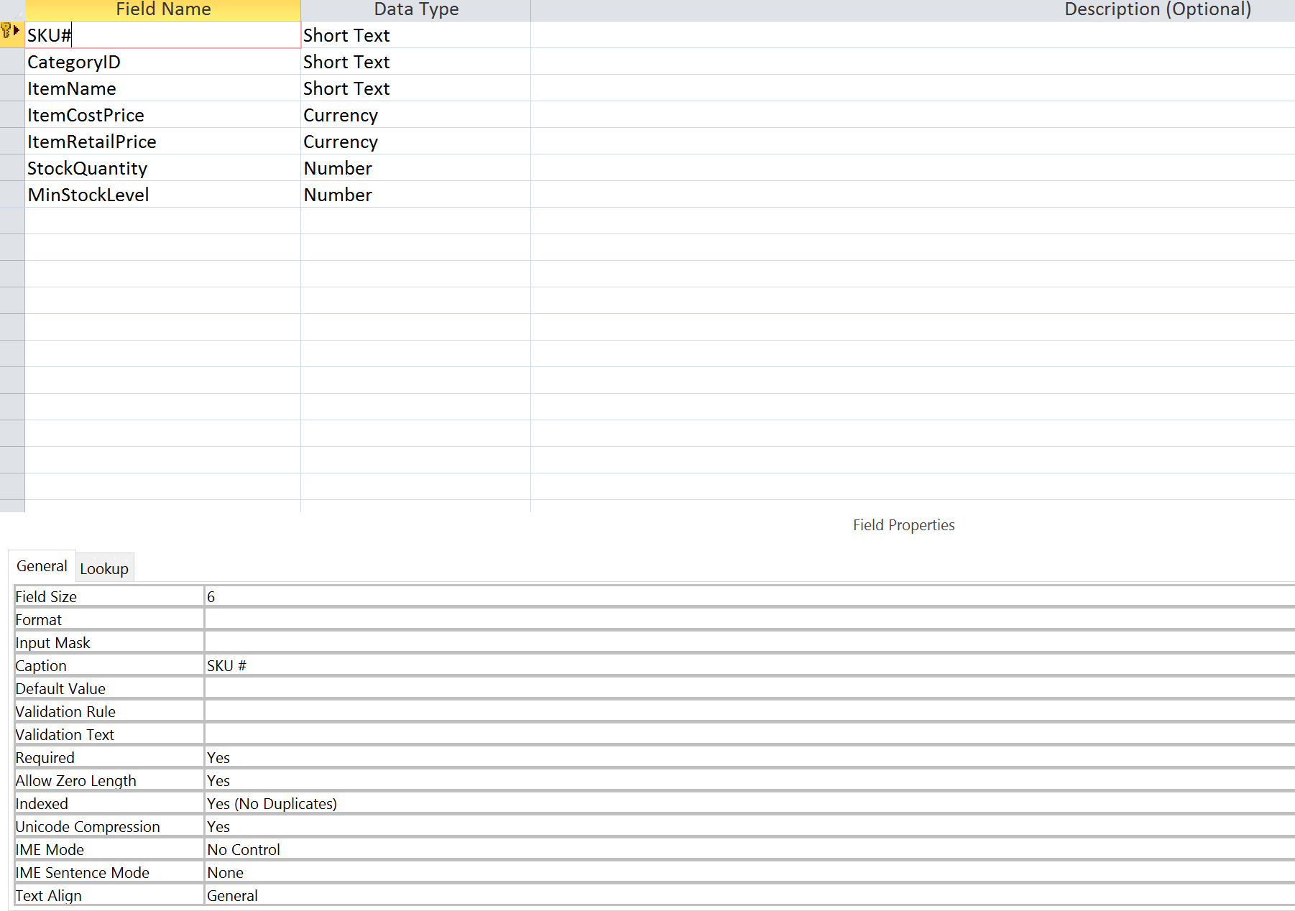

1. **Inventory Table**

| **Inventory** | | | | | | |
| --- | --- | --- | --- | --- | --- | --- |
| **SKU #** | **Category ID** | **Item Name** | **Item Cost** | **Item Retail Price** | **Quantity in Stock** | **Minimum Stock Level** |
| CC1157 | 1 | Coat Curry | $2.00 | $10.00 | 15 | 5 |
| FF4324 | 2 | Fido Feast | $0.50 | $1.50 | 100 | 25 |
| GI1562 | 3 | Gnaw-It | $1.50 | $7.00 | 20 | 10 |
| KK2212 | 3 | Krazy Kat | $2.00 | $8.95 | 30 | 10 |
| MC1011 | 2 | MaxCat | $0.10 | $0.90 | 100 | 30 |
| TL2156 | 1 | Trimline | $1.00 | $6.95 | 25 | 10 |

1. **ItemCategory Table Design View**

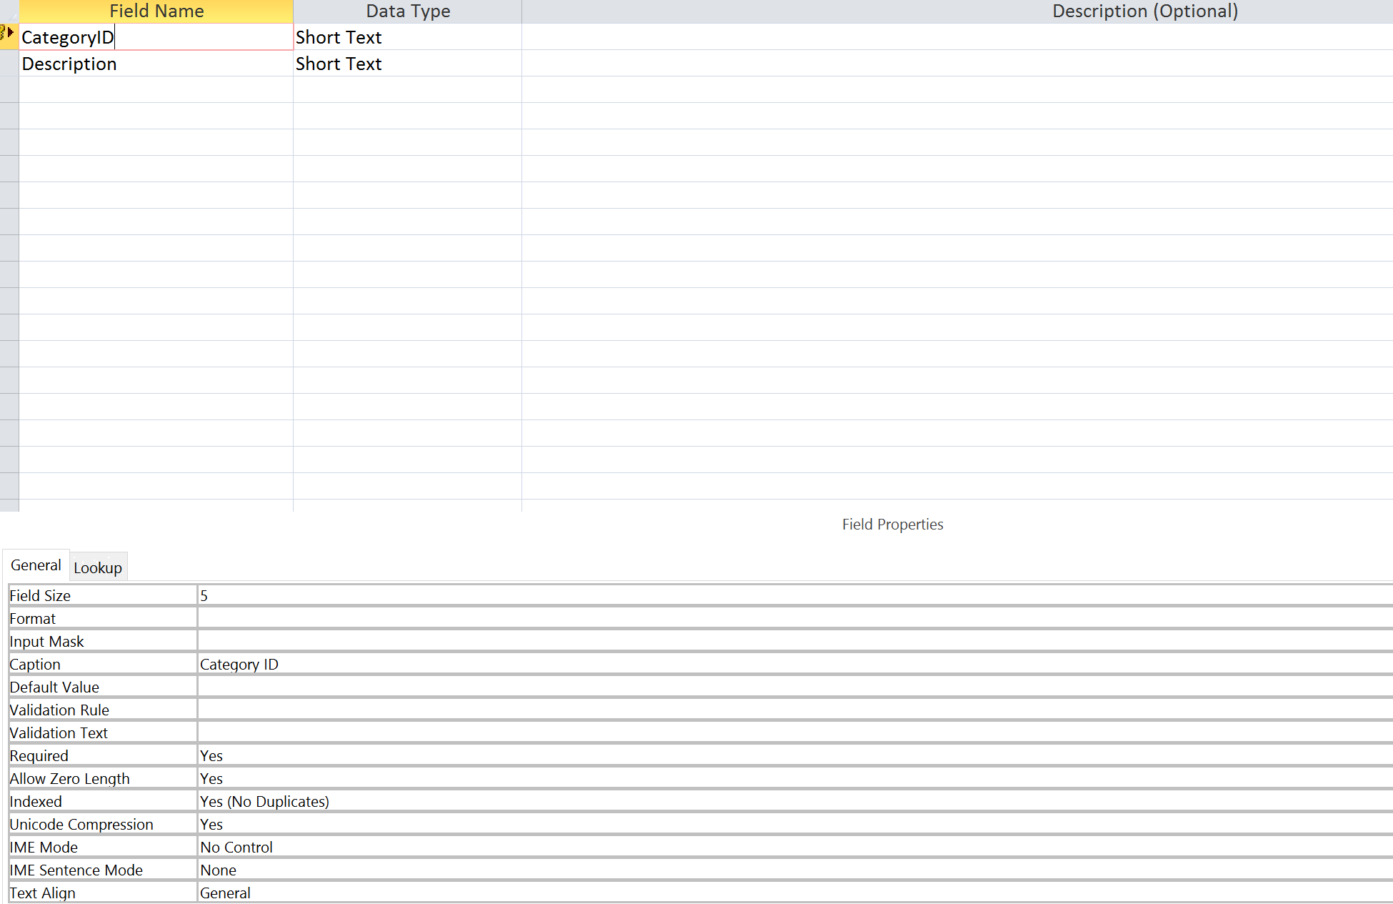

1. **ItemCategory Table**

| **ItemCategory** | |
| --- | --- |
| **Category ID** | **Description** |
| 1 | Grooming |
| 2 | Food |
| 3 | Toys |

1. **CustomerInfo Query Design**

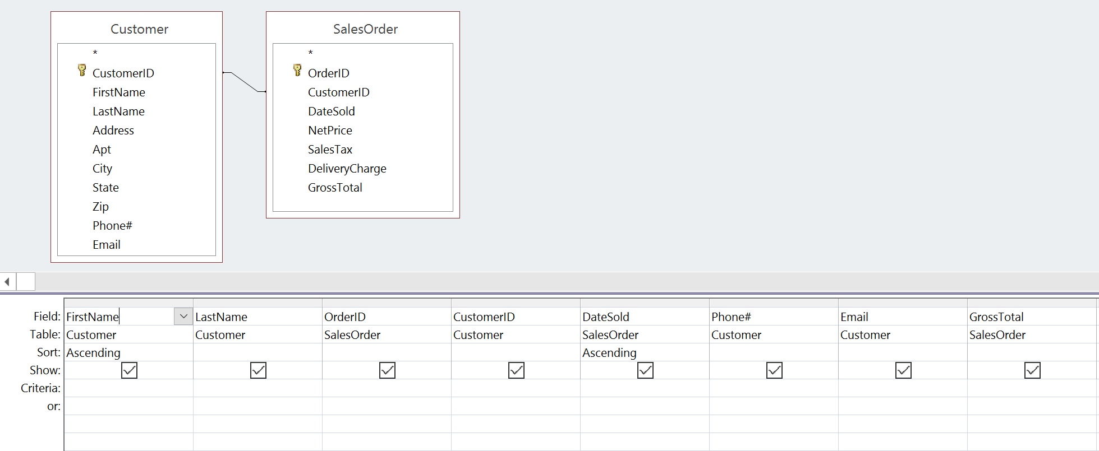

1. **CustomerInfo Query Results**

| **CustomerInfo** | | | | | | | |
| --- | --- | --- | --- | --- | --- | --- | --- |
| **First Name** | **Last Name** | **Order ID** | **Customer ID** | **Date Sold** | **Phone#** | **Email** | **Gross Total** |
| Aminova | Terry | S0007 | A9874 | 02/25/2015 | (347) 555-5432 | T.Aminova@nyc.gov | $33.62 |
| Morales | Amanda | S0002 | M1121 | 02/13/2015 | (212) 767-9876 | morales@metmuseum.org | $50.46 |
| Morales | Amanda | S0005 | M1121 | 02/21/2015 | (212) 767-9876 | morales@metmuseum.org | $19.28 |
| Morales | Amanda | S0015 | M1121 | 03/01/2015 | (212) 767-9876 | morales@metmuseum.org | $42.91 |
| Patel | Vincent | S0006 | P0101 | 02/25/2005 | (646) 432-1231 | V_Patel@verizon.net | $54.26 |
| Patel | Vincent | S0003 | P0101 | 02/14/2015 | (646) 432-1231 | V_Patel@verizon.net | $19.55 |
| Tsang | Elise | S0001 | T4291 | 02/10/2015 | (212) 545-4321 | ET@aol.com | $52.69 |
| Tsang | Elise | S0004 | T4291 | 02/14/2015 | (212) 545-4321 | ET@aol.com | $109.28 |

1. **InventoryLookup Query Design**

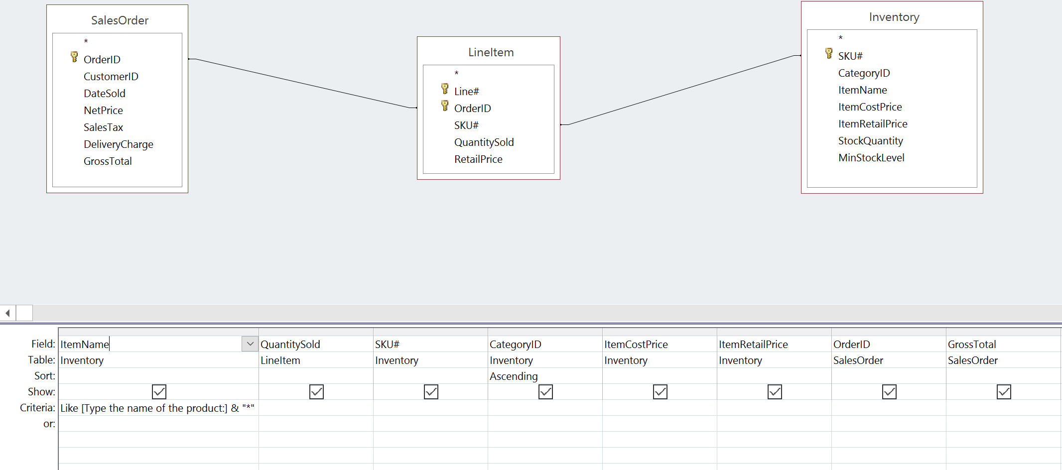

1. **InventoryLookup Query Results**

| **InventoryLookup** | | | | | | | |
| --- | --- | --- | --- | --- | --- | --- | --- |
| **Category ID** | **Item Name** | **SKU #** | **Quantity Sold** | **Order ID** | **Item Cost** | **Item Retail Price** | **Gross Total** |
| 1 | Trimline | TL2156 | 1 | S0007 | $1.00 | $6.95 | $33.62 |
| 1 | Trimline | TL2156 | 1 | S0006 | $1.00 | $6.95 | $54.26 |
| 1 | Trimline | TL2156 | 1 | S0005 | $1.00 | $6.95 | $19.28 |
| 1 | Trimline | TL2156 | 2 | S0001 | $1.00 | $6.95 | $52.69 |
| 1 | Trimline | TL2156 | 1 | S0002 | $1.00 | $6.95 | $50.46 |
| 1 | Coat Curry | CC1157 | 1 | S0007 | $2.00 | $10.00 | $33.62 |
| 1 | Coat Curry | CC1157 | 1 | S0004 | $2.00 | $10.00 | $109.28 |
| 2 | MaxCat | MC1011 | 24 | S0015 | $0.10 | $0.90 | $42.91 |
| 2 | MaxCat | MC1011 | 12 | S0005 | $0.10 | $0.90 | $19.28 |
| 2 | MaxCat | MC1011 | 24 | S0002 | $0.10 | $0.90 | $50.46 |
| 2 | Fido Feast | FF4324 | 12 | S0003 | $0.50 | $1.50 | $19.55 |
| 2 | Fido Feast | FF4324 | 20 | S0001 | $0.50 | $1.50 | $52.69 |
| 2 | Fido Feast | FF4324 | 24 | S0006 | $0.50 | $1.50 | $54.26 |
| 2 | Fido Feast | FF4324 | 48 | S0004 | $0.50 | $1.50 | $109.28 |
| 3 | Krazy Kat | KK2212 | 2 | S0002 | $2.00 | $8.95 | $50.46 |
| 3 | Gnaw-It | GI1562 | 2 | S0004 | $1.50 | $7.00 | $109.28 |
| 3 | Gnaw-It | GI1562 | 1 | S0006 | $1.50 | $7.00 | $54.26 |
| 3 | Krazy Kat | KK2212 | 2 | S0015 | $2.00 | $8.95 | $42.91 |
| 3 | Gnaw-It | GI1562 | 2 | S0007 | $1.50 | $7.00 | $33.62 |

| **InventoryLookup** | | | | | | | |
| --- | --- | --- | --- | --- | --- | --- | --- |
| **Category ID** | **Item Name** | **SKU #** | **Quantity Sold** | **Order ID** | **Item Cost** | **Item Retail Price** | **Gross Total** |
| 1 | Trimline | TL2156 | 1 | S0002 | $1.00 | $6.95 | $50.46 |
| 1 | Trimline | TL2156 | 1 | S0007 | $1.00 | $6.95 | $33.62 |
| 1 | Trimline | TL2156 | 1 | S0006 | $1.00 | $6.95 | $54.26 |
| 1 | Trimline | TL2156 | 1 | S0005 | $1.00 | $6.95 | $19.28 |
| 1 | Trimline | TL2156 | 2 | S0001 | $1.00 | $6.95 | $52.69 |

1. **SalesOrder Form Design**

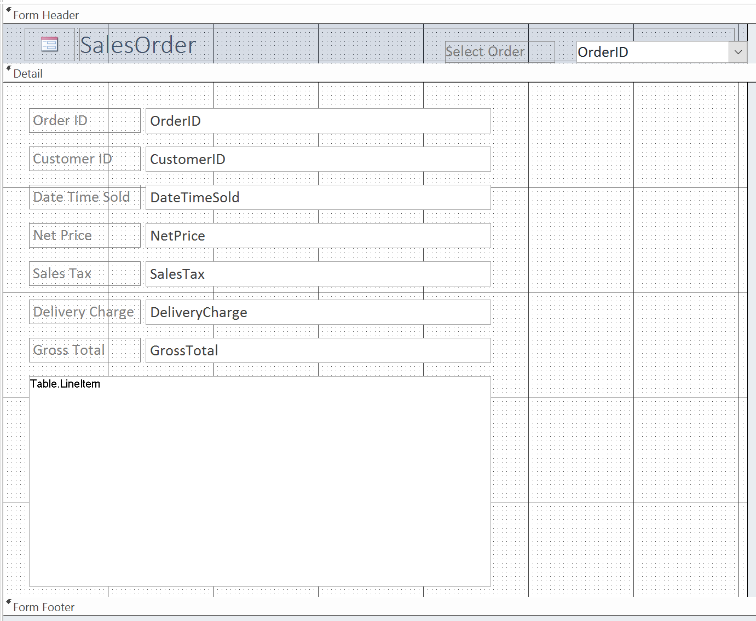

1. **SalesOrder Form**

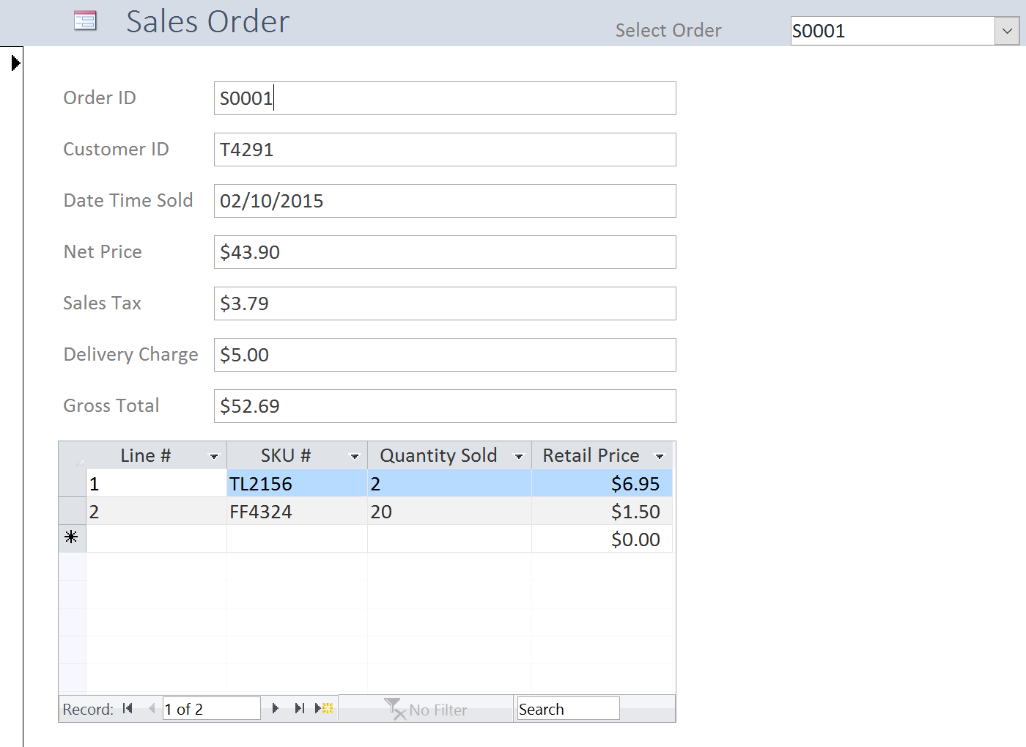

1. **Customer Multi-Table View**

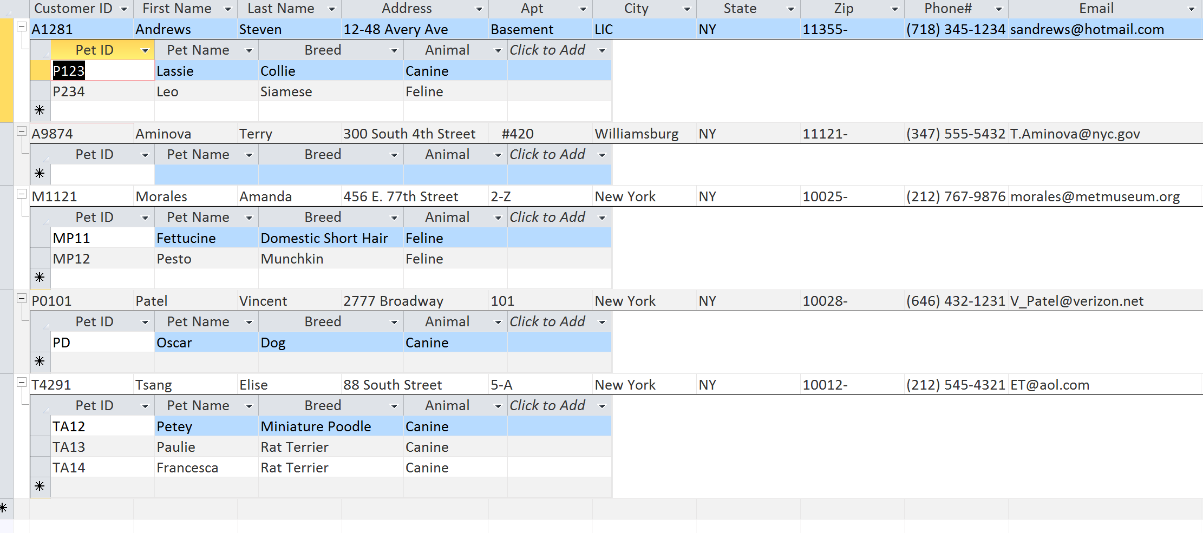

1. **Totals Report Design View**

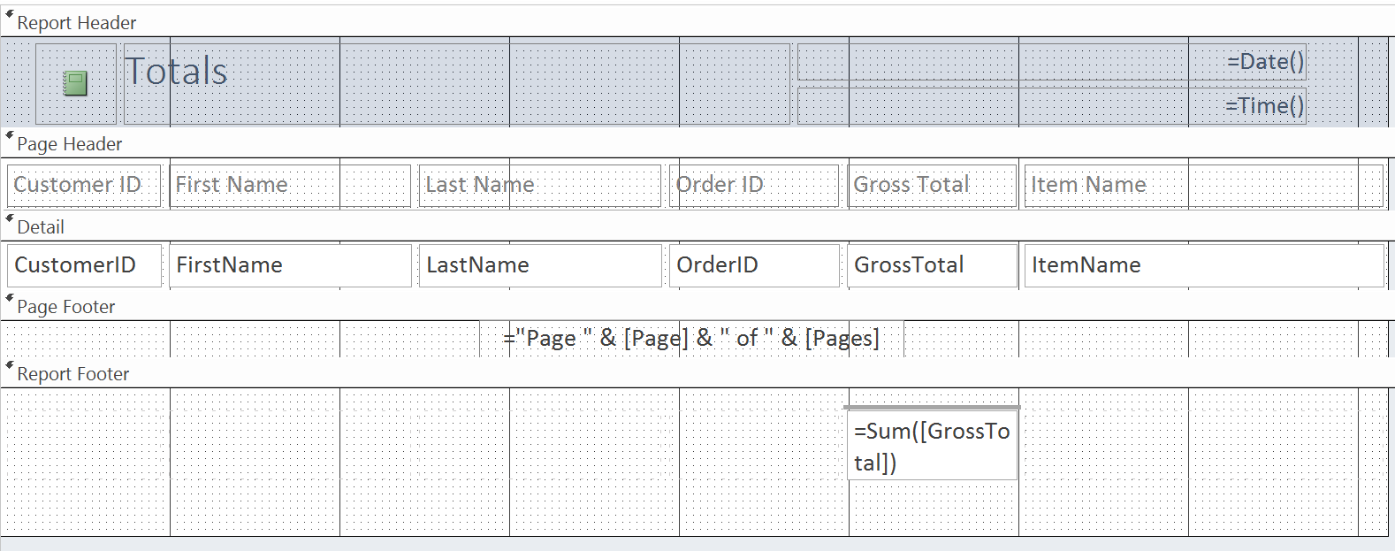

1. **Totals Report**

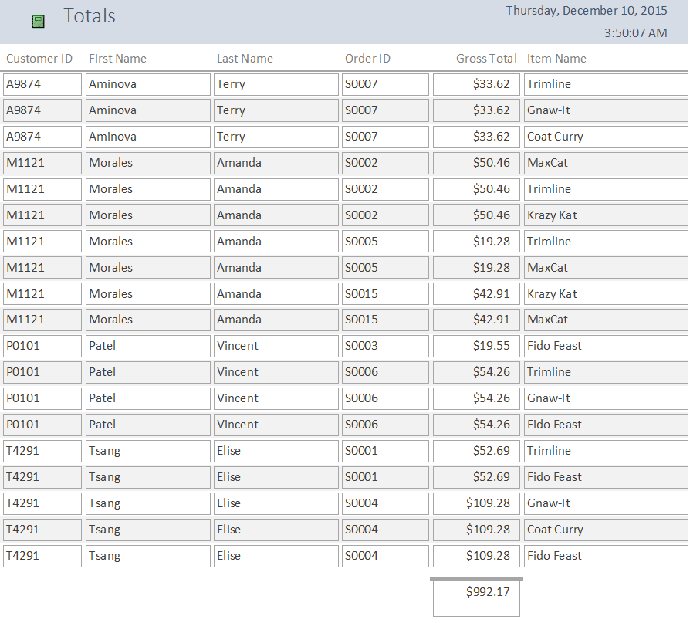

1. **Sub Report Design View**

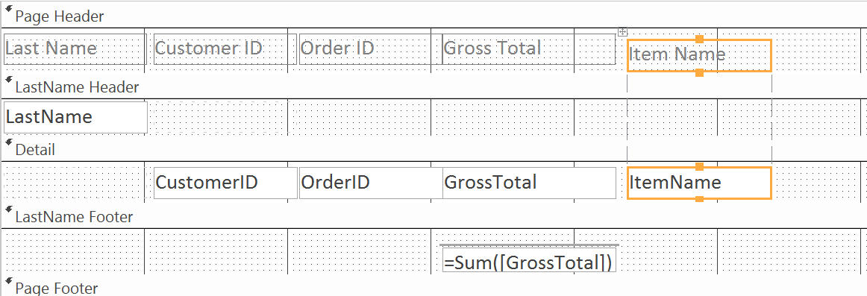

1. **Sub Report**

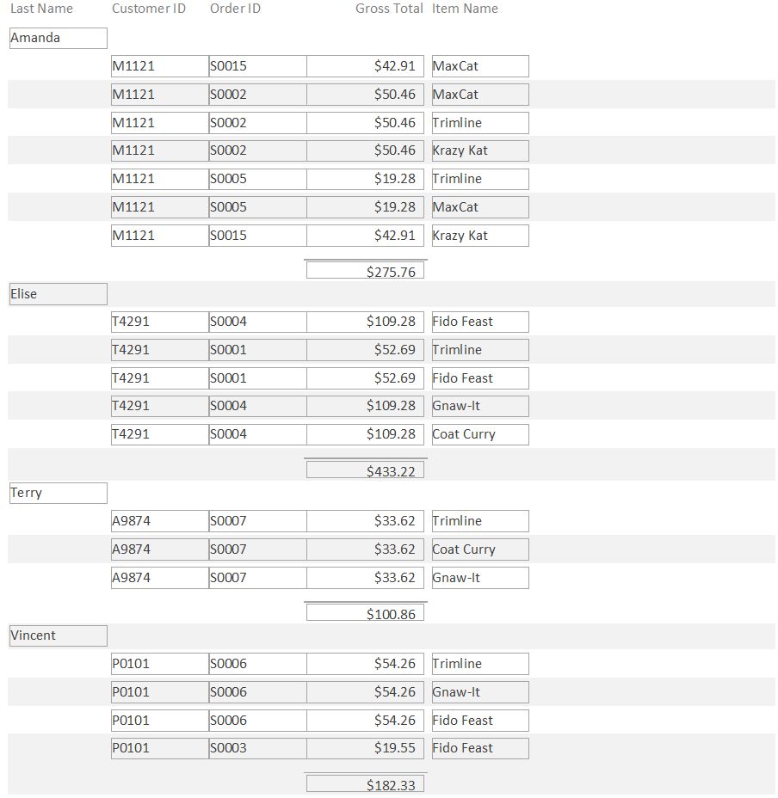

1. **Switchboard**

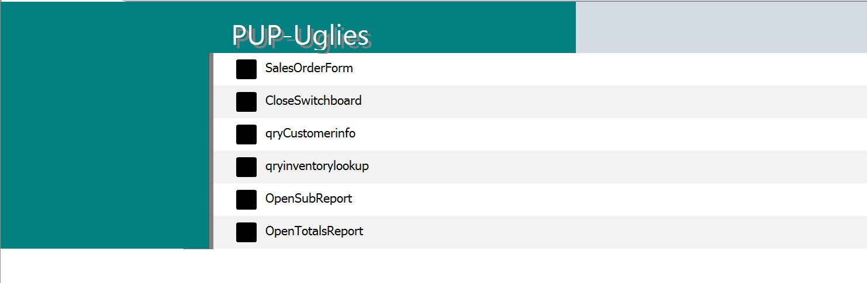

1. **SalesOrderForm Macro Design**

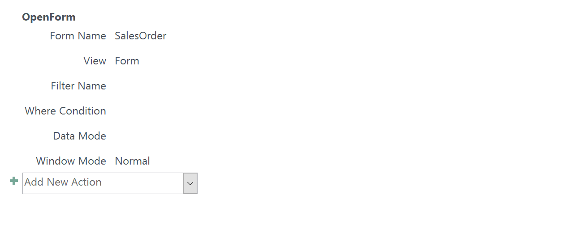**AA. qryCustomerInfo Macro Design**

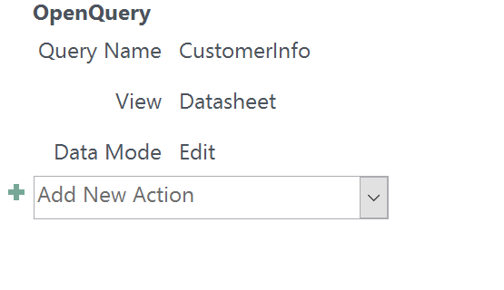

**BB. qryInventoryLookup Macro Design**

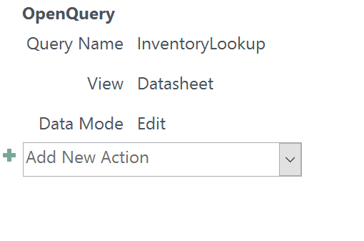

**CC. TotalsReport Macro Design**

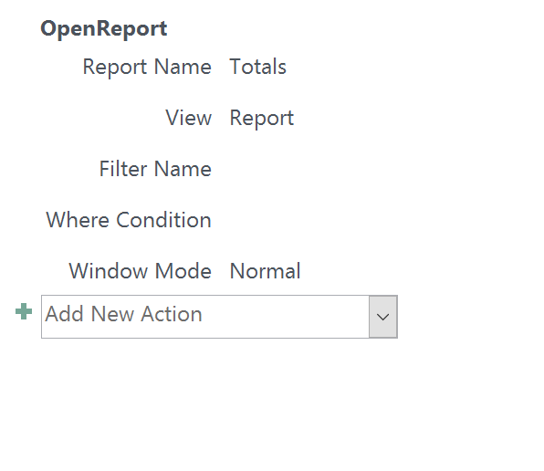

**DD. Sub Report Macro Design**

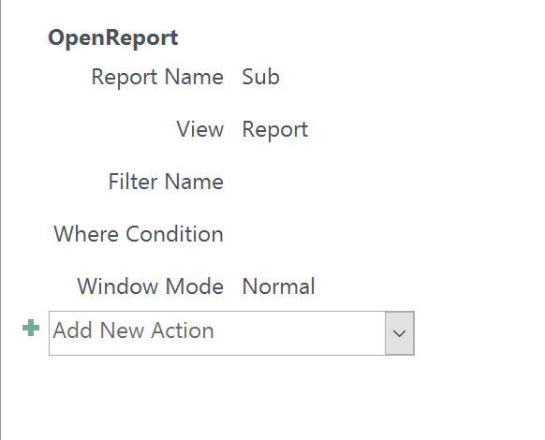

**EE. CloseSwitchboard Macro Design**

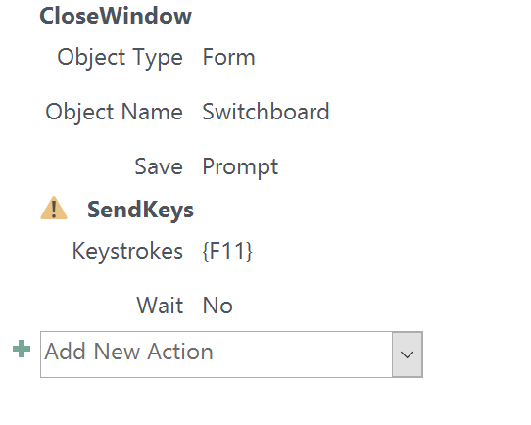

**FF. CloseSwitchboard VBA Code**

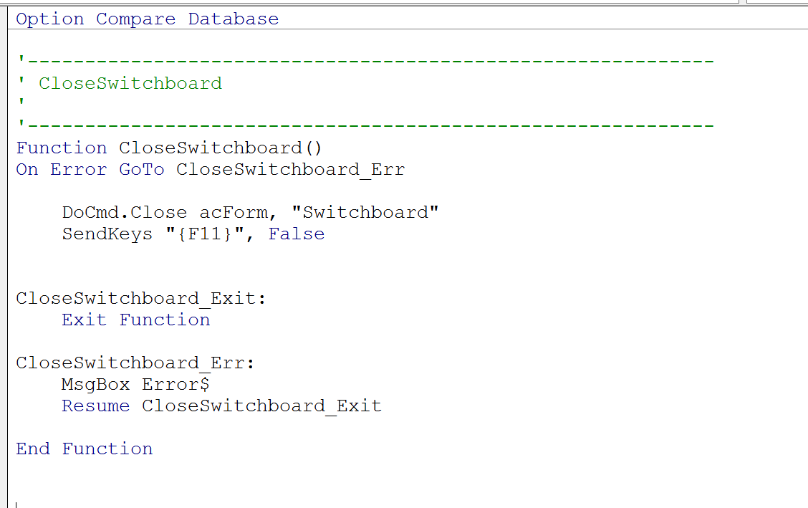

**Narrative Conclusion**

We enjoyed working for the project and creating a Database System(DBS) that PUP can use to help improve their business model, and do hope to watch as PUP grows into the next PetCo (fingers crossed!). It was a very productive learning experience as it helped all of us to better understand the theoretical concepts and their application in a real time scenario. Regular communication within the team, focused approach for issues at hand and continuous iterations significantly contributed to successful completion of the project. The work division within team members for timely completion of this milestone is as given below.

* Adam was responsible for the narrative and the queries
* Guan completed the switchboard
* Jafor and Mathew completed the total and sub report
* As team leader, Shobhit compiled the full project report. Further, he also created the form along with a sub form for line items, and a combo box at the top so the user can scroll to his/her sales order.

As for the PUP project we found that in addition to Project Management, the ERD and Normalization were most difficult as it required a clear conceptual understating of the Database. Mapping these concepts right was cardinal to successful completion of the project. Further getting a clear understanding of user requirements and logically connecting their processes was also challenging. Implementing normalized relations to relational database in MS Access was probably the easiest part. Developing queries, forms, reports and switchboard were moderately tough.

But for this project, we would not have realized the importance of DBS in efficient business operations and corporate decision making. Using the database we can pinpoint any slow sellers in the pet-shop, and use this information to make informed decisions regarding whether or not to keep that item in stock. We can also use the database to analyze customer preferences, and items purchased for better layout of store inventory, the way we advertise, and who we advertise to. With the use of basic queries on a database we can optimize our profits through many angles. If we had to do this all over again we would have developed a more detailed ERD that also included features such as a reward points card for customers to increase customer loyalty.

We have been able to achieve all the necessary business processes that PUP must perform. While we were able to organize the data for PUP to overcome their current issues and make effective decisions, we have not really extended the power of automated DBS to the customers. We wanted to improve customer loyalty, but gave no solid strategy in doing so; we just organized the data well enough to support future decision making. At this point in time there is no connect between the DBS and customer loyalty. Adding feature like loyalty cards would bridge the gap and complete the loop between PUP and its customers. Besides this handicap, our DBS is capable to address all issues we envisaged to resolve.